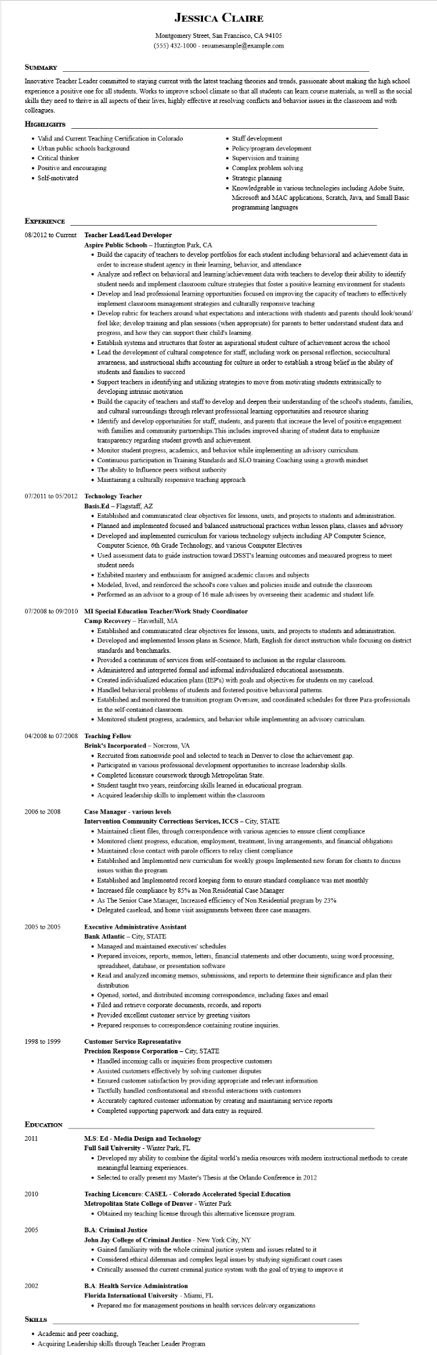
JESSICA CLAIRE
Montgomery Street, San Francisco, CA 94105 (555) 432-1000 - resumesample@example.com
SUMMARY
Innovative Teacher Leader committed to staying current with the latest teaching theories and trends, passionate about making the high school experience a positive one for all students. Works to improve school climate so that all students can learn course materials, as well as the social skills they need to thrive in all aspects of their lives, highly effective at resolving conflicts and behavior issues in the classroom and with colleagues.
HIGHLIGHTS
• Valid and Current Teaching Certification in Colorado
• Urban public schools background
• Critical thinker
• Positive and encouraging
Self-motivated
• Staff development
• Policy/program development
Supervision and training
• Complex problem solving
Strategic planning
• Knowledgeable in various technologies including Adobe Suite, Microsoft and MAC applications, Scratch, Java, and Small Basic programming languages
EXPERIENCE
08/2012 to Current Teacher Lead/Lead Developer
Aspire Public Schools - Huntington Park, CA
• Build the capacity of teachers to develop portfolios for each student including behavioral and achievement data in order to increase student agency in their learning, behavior, and attendance
• Analyze and reflect on behavioral and learning/achievement data with teachers to develop their ability to identify student needs and implement classroom culture strategies that foster a positive learning environment for students
• Develop and lead professional learning opportunities focused on improving the capacity of teachers to effectively implement classroom management strategies and culturally responsive teaching
• Develop rubric for teachers around what expectations and interactions with students and parents should look/sound/ feel like; develop training and plan sessions (when appropriate) for parents to better understand student data and progress, and how they can support their child's learning.
• Establish systems and structures that foster an aspirational student culture of achievement across the school
• Lead the development of cultural competence for staff, including work on personal reflection, sociocultural awareness, and instructional shifts accounting for culture in order to establish a strong belief in the ability of students and families to succeed
• Support teachers in identifying and utilizing strategies to move from motivating students extrinsically to developing intrinsic motivation
• Build the capacity of teachers and staff to develop and deepen their understanding of the school's students, families, and cultural surroundings through relevant professional learning opportunities and resource sharing
• Identify and develop opportunities for staff, students, and parents that increase the level of positive engagement with families and community partnerships. This includes improved sharing of student data to emphasize transparency regarding student growth and achievement.
• Monitor student progress, academics, and behavior while implementing an advisory curriculum.
• Continuous participation in Training Standards and SLO training Coaching using a growth mindset
• The ability to Influence peers without authority
• Maintaining a culturally responsive teaching approach
07/2011 to 05/2012 Technology Teacher
Basis.Ed - Flagstaff, AZ
• Established and communicated clear objectives for lessons, units, and projects to students and administration.
• Planned and implemented focused and balanced instructional practices within lesson plans, classes and advisory
• Developed and implemented curriculum for various technology subjects including AP Computer Science, Computer Science, 6th Grade Technology, and various Computer Electives
• Used assessment data to guide instruction toward DSST's learning outcomes and measured progress to meet student needs
• Exhibited mastery and enthusiasm for assigned academic classes and subjects
• Modeled, lived, and reinforced the school's core values and policies inside and outside the classroom
• Performed as an advisor to a group of 16 male advisees by overseeing their academic and student life.
07/2008 to 09/2010 MI Special Education Teacher/Work Study Coordinator
Camp Recovery - Haverhill, MA
• Established and communicated clear objectives for lessons, units, and projects to students and administration.
• Developed and implemented lesson plans in Science, Math, English for direct instruction while focusing on district standards and benchmarks.
• Provided a continuum of services from self-contained to inclusion in the regular classroom.
• Administered and interpreted formal and informal individualized educational assessments.
• Created individualized education plans (IEP's) with goals and objectives for students on my caseload.
• Handled behavioral problems of students and fostered positive behavioral patterns.
• Established and monitored the transition program Oversaw, and coordinated schedules for three Para-professionals in the self-contained classroom.
• Monitored student progress, academics, and behavior while implementing an advisory curriculum.
04/2008 to 07/2008 Teaching Fellow
2006 to 2008
Brink's Incorporated - Norcross, VA
• Recruited from nationwide pool and selected to teach in Denver to close the achievement gap.
• Participated in various professional development opportunities to increase leadership skills.
• Completed licensure coursework through Metropolitan State.
• Student taught two years, reinforcing skills learned in educational program.
• Acquired leadership skills to implement within the classroom
Case Manager - various levels
Intervention Community Corrections Services, ICCS - City, STATE
• Maintained client files, through correspondence with various agencies to ensure client compliance
• Monitored client progress, education, employment, treatment, living arrangements, and financial obligations
• Maintained close contact with parole officers to relay client compliance
• Established and Implemented new curriculum for weekly groups Implemented new forum for clients to discuss issues within the program
• Established and Implemented record keeping form to ensure standard compliance was met monthly
• Increased file compliance by 85% as Non Residential Case Manager
• As The Senior Case Manager, Increased efficiency of Non Residential program by 23%
• Delegated caseload, and home visit assignments between three case managers.
Executive Administrative Assistant
2005 to 2005
Bank Atlantic - City, STATE
• Managed and maintained executives' schedules
• Prepared invoices, reports, memos, letters, financial statements and other documents, using word processing, spreadsheet, database, or presentation software
• Read and analyzed incoming memos, submissions, and reports to determine their significance and plan their distribution
• Opened, sorted, and distributed incoming correspondence, including faxes and email
• Filed and retrieve corporate documents, records, and reports
• Provided excellent customer service by greeting visitors
• Prepared responses to correspondence containing routine inquiries.
1998 to 1999
Customer Service Representative
Precision Response Corporation - City, STATE
EDUCATION
2011
2010
• Handled incoming calls or inquiries from prospective customers
• Assisted customers effectively by solving customer disputes
• Ensured customer satisfaction by providing appropriate and relevant information
• Tactfully handled confrontational and stressful interactions with customers
• Accurately captured customer information by creating and maintaining service reports
• Completed supporting paperwork and data entry as required.
M.S: Ed - Media Design and Technology
Full Sail University - Winter Park, FL
• Developed my ability to combine the digital world's media resources with modern instructional methods to create meaningful learning experiences.
• Selected to orally present my Master's Thesis at the Orlando Conference in 2012
Teaching Licencure: CASEL - Colorado Accelerated Special Education
Metropolitan State College of Denver - Winter Park
• Obtained my teaching license through this alternative licensure program.
2005
B.A: Criminal Justice
John Jay College of Criminal Justice - New York City, NY
2002
SKILLS
• Gained familiarity with the whole criminal justice system and issues related to it
• Considered ethical dilemmas and complex legal issues by studying significant court cases
• Critically assessed the current criminal justice system with the goal of trying to improve it
B.A: Health Service Administration
Florida International University - Miami, FL
• Prepared me for management positions in health services delivery organizations
• Academic and peer coaching,
• Acquiring Leadership skills through Teacher Leader Program

